GE04 Documentation

**Jacob Hartt, Takaiya Jones, Jacob Biles and Zachary Rytting**

Professor Deb Harding  
CS3300.002  
03.16.2024

SECTION 2.4 Portfolio Details

Issues Encountered

Useful Resources

SECTION 2.7 Student List

Issues Encountered

Useful Resources

SECTION 2.8 Student Details

Issues Encountered

Useful Resources

# SECTION 2.4 Portfolio Details

The focus of section 2.4 surrounds the setup of the portfolio .html. In this section I created the portfolio_details.html. Pulling from the home page, I was able to easily create the main details of contact email, about and active. Using the generic template I implemented the features given from the portfolio model as seen here: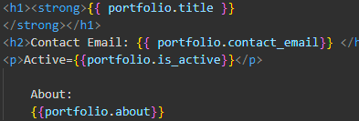

Creating the projects

* creating the projects was the most difficult part. First with the generic form, I had to give it context. This meant that I had to use the context feature of the generic form, so it could access all projects filtered to that portfolio.

Button Shenanigans

* to display the buttons nicely, I kept them all in the same paragraph, and changed their color. For the first two I used the standard templates for a primary button and a secondary button respectively. For the third, I created a custom color using a color wheel to get a more muted red from the vibrant one that came with
  + using 0x882222, I created a better color, and then added a style to the base template named “btn-delete-red”,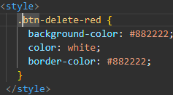
  + which I could then use as the class for the delete button
  + 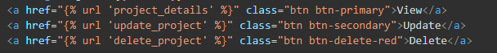

## Issues Encountered

* I did not initially use the generic templates, causing a massive headache for myself. This was eventually fixed when I formatted it properly, and took the time to reread the lecture notes. I created a new version to undo all of my work that ended up being for nothing, just in case my latest iteration was a failure as well. However I was able to successfully get it to work.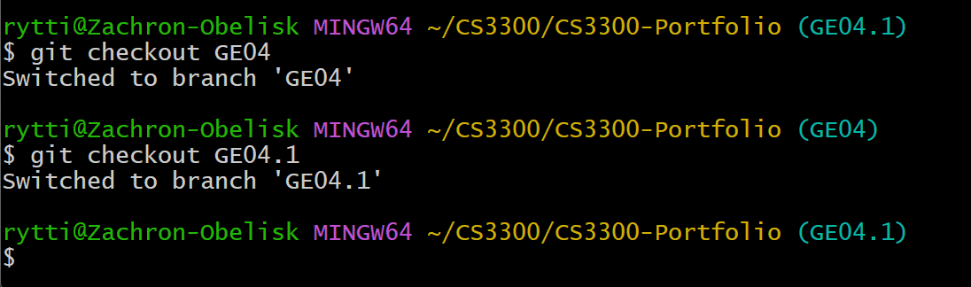
* and was able to merge it back onto the GE04 branch
* 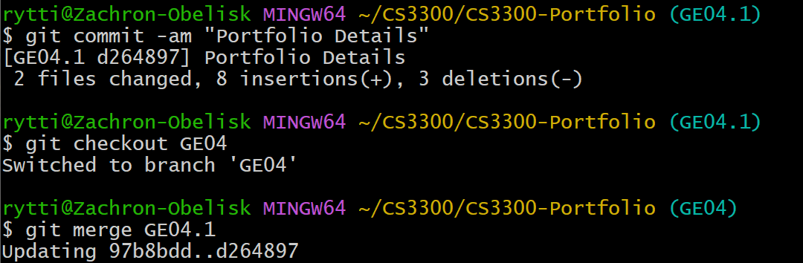

## Useful Resources

* <https://canvas.uccs.edu/courses/152505/pages/l13-django-model-view-template?module_item_id=2446089>
  + This shows the generic views provided.
* <https://www.canva.com/colors/color-wheel/>
  + this is useful for customizing the various buttons in order
* <https://www.w3schools.com/bootstrap/bootstrap_buttons.asp>
  + brief overview of bootstrap’s buttons
* <https://www.freecodecamp.org/news/css-button-style-hover-color-and-background/>
  + button setup
* <https://docs.djangoproject.com/en/4.2/topics/class-based-views/generic-display/>
  + for generic template aid

# SECTION 2.7 Student List

* Creating the student list was fairly straightforward. First, set up the generic list view provided. This allows the url to be set up correctly, giving all needed context,

## Issues Encountered

* I had an issue where I set up my one-to-one connection in my student object, so the id it used was actually the portfolio id, and was therefore renamed by django. I had to play around a bunch in order to discover the problem, then renamed the variable to work correctly. 

## Useful Resources

* <https://canvas.uccs.edu/courses/152505/pages/l13-django-model-view-template?module_item_id=2446089>

# SECTION 2.8 Student Details

* This was incredibly easy to set up. The main details is very similar to the portfolio details, so look at that to figure out how to set up most of the issues. The only complicated thing is setting up the absolute url of the portfolio. In the end, the same method used in Student List works here, where the get_absolute_url links properly to the url of the portfolio.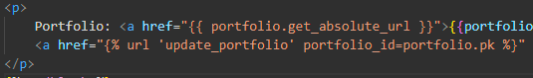

## Issues Encountered

None.

## Useful Resources

None.